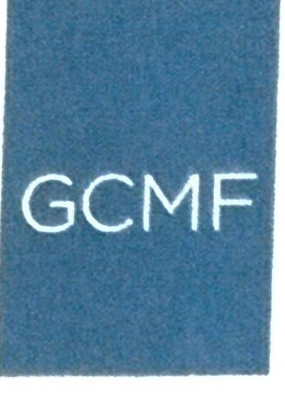
THE
GEORGE C. MARSHALL FOUN DATI ON

Permission to Publish Form
Permission is granted for one-time, non-exclusive, world-wide rights, in the medium specified. This agreement applies only to the project specified in this agreement.
Permission is granted for one edition of a publication (defined as any number of reprintings whereby the text remains essentially unchanged) or for a single video, digital, television, or film production for the life of the production with unlimited rebroadcasts.

Format of Publication:
__Book
__ Periodical
__ Film/Video
__ Exhibit
__ Website w URL
__ Other

Images to be published: (please include catalog number)

For images from the Research Library, please use the following credit line:
Courtesy of the George C. Marshall Foundation, Lexington, Virginia.

Any fees required for permission to publish will be indicated here: $ 0

I/we agree to the conditions above:

Name:_______________________________________________________________________________
Company:____________________________________________________________________________
Address:_____________________________________________________________________________
Phone number:______________________________________ email:___________________________
Signature:__________________________________________ Date:____________________________

__________________________________________________ Date:____________________________
Signature of Marshall Foundation staff

