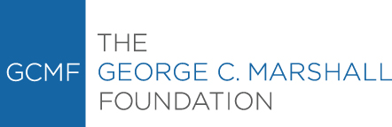

Permission to Publish Form
Permission is granted for one-time, non-exclusive, world-wide rights, in the medium specified. This agreement applies only to the project specified in this agreement.
Permission is granted for one edition of a publication (defined as any number of reprintings whereby the text remains essentially unchanged) or for a single video, digital, television, or film production for the life of the production with unlimited rebroadcasts.

Format of Publication:
Book
Periodical
Film/Video
Exhibit
Website w URL
Other

Images and documents to be published: (please include catalog number)
GCM 1234
Where will the item (s) be published? ____________________________________________________
Please send a copy of the published item, or in the case of born digital, a link/citation.

Please use the following credit line:
Courtesy of the George C. Marshall Foundation, Lexington, Virginia.

Fees required for permission to publish:

I/we agree to the conditions above:

Name:_______________________________________________________________________________
Company:____________________________________________________________________________
Address:_____________________________________________________________________________
Phone number:______________________________________ email:___________________________
Signature:__________________________________________ Date:____________________________

__________________________________________________ Date:____________________________
Signature of Marshall Foundation staff

